## **Presidio Day 14 Screenshots :**

LeetCode 1 :[Minimum Depth of Binary Tree - LeetCode](https://leetcode.com/problems/minimum-depth-of-binary-tree/submissions/1244828158/)

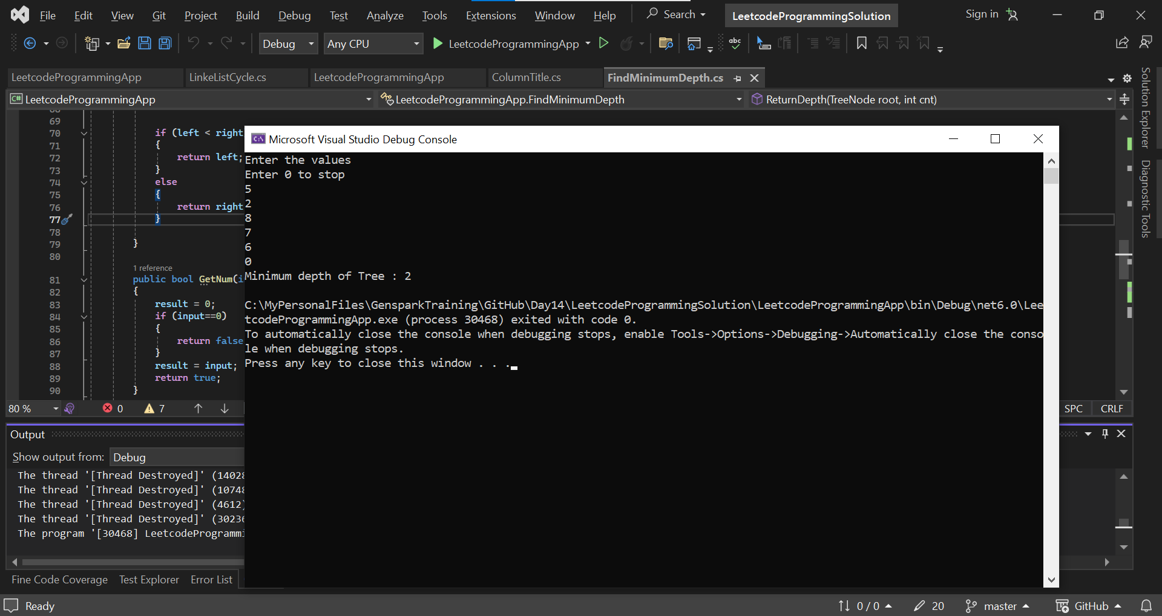

LeetCode 2 :[Excel Sheet Column Title - LeetCode](https://leetcode.com/problems/excel-sheet-column-title/submissions/1244882948/)

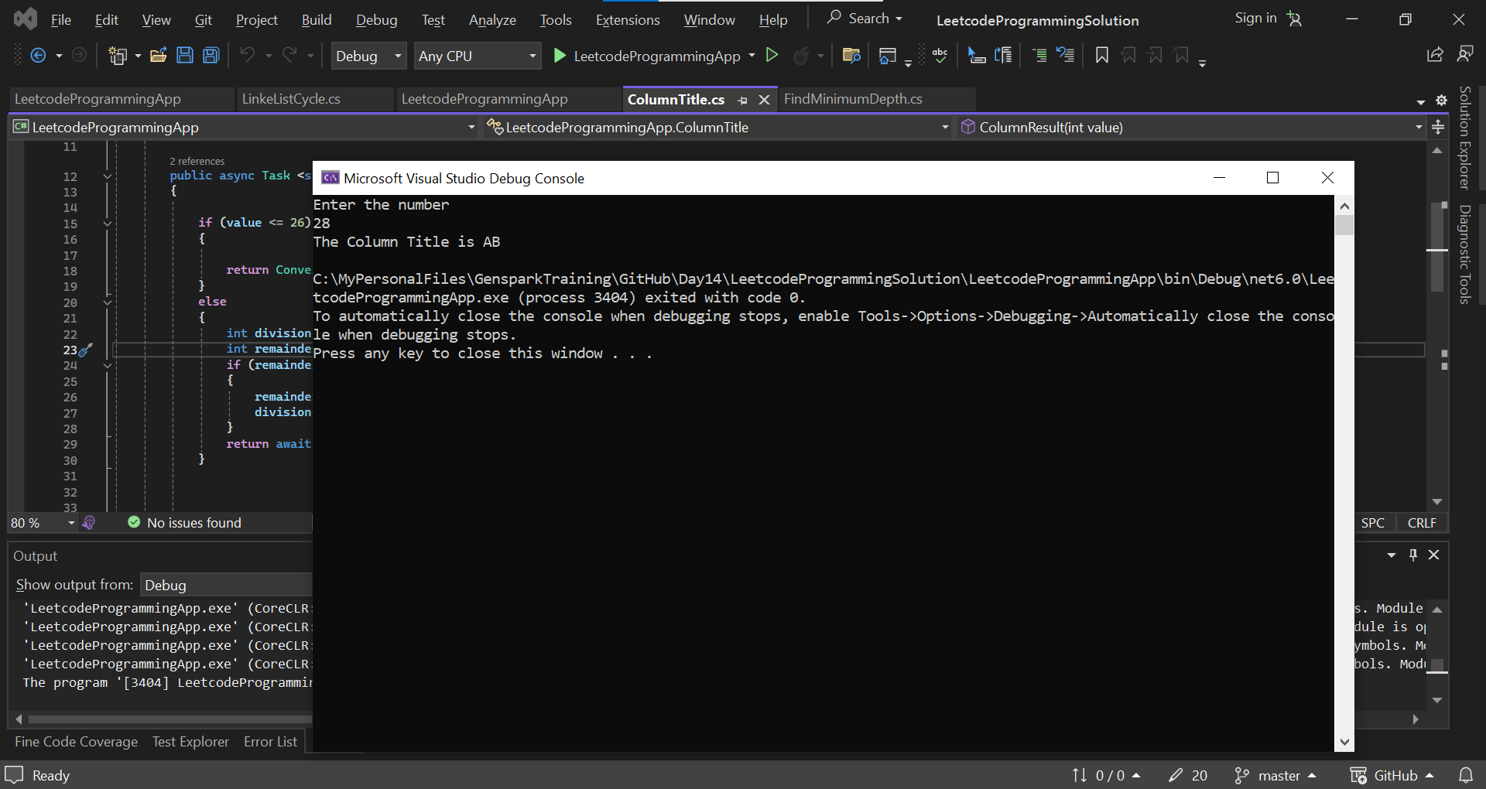

LeetCode 3 :[Linked List Cycle - LeetCode](https://leetcode.com/problems/linked-list-cycle/)

